**Govt. College University, Faisalabad**

Department of _____________________Computer Science_______________________

Synopsis for MS Degree

Title: ___________________________________________________________________

Name of Student:_________________________________________________________

Registration No:__________________________________________________________

**ABSTRACT**

**Govt. College University, Faisalabad**

Department of _____________________Computer Science____________________________

Synopsis for MS Degree

Title: ________________________________________________________________________

Date of Admission: ____________________________________________________________

Date of Initiation: ______________________________________________________________

Probable Duration: _____________________________________________________________

**Supervisory Committee**

1) __________________________ Chairman

2) __________________________ Co-Supervisor (if any)

3) __________________________ Member

4) __________________________ Member

**Introduction: (minimum one page)**

*Problem Background*: (minimum half page)

*Problem Statement*: (maximum half page)

*Research Questions*: (At least one)



*Objectives*: (At least one , must map to research questions, each objective should be comparable and measurable)



*Scope*: (minimum half page)

*Motivation:* (minimum half page)

Significance: (minimum half page)

**Literature Review : (minimum two pages, must contain table identifying core paper, must highlight limitations of the core paper)**

**Material and Method: (minimum one page, must discuss the methodology of the compared/core papers)**

*Existing techniques and methodology:* (minimum one page, identify all compared techniques, identify their limitations technically)

*Research design and procedure:* (minimum one page, discuss the research design of the compared paper)

*Evaluation method:* (minimum one page, discuss all the evaluation methods used by the compared studies, identify the validation methods used by the compared study)

*Dataset:* (minimum one page, discuss the dataset in detail)

*Research Plan*: (minimum one page. Discuss the plan in detail)

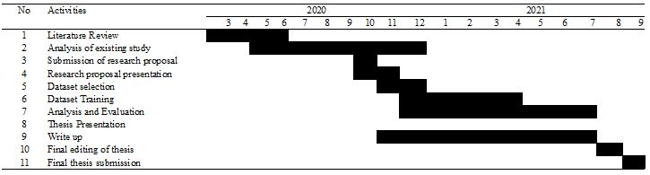

*Preliminary Findings:* (must write the preliminary findings, experiment setup, initial results)

**References**

APA Style

**Signatures**

Name of the Student: __________________________ ___________________

**Supervisory Committee (Name and Signatures)**

1. ___________________________ Supervisor ___________________

2. ___________________________ Co-Supervisor (if any) ___________________

3. ___________________________ Member ___________________

4. ___________________________ Member ___________________

Faculty Scrutiny Committee (Name and Signatures)

1. _______________________________ ___________________

2. _______________________________ ___________________

3. _______________________________ ___________________

4. _______________________________ ___________________

__________________________________ ____________________________________

Chairman / Principal / Director Dean of the Faculty

of the Department / College / Institute

________________________________________

Director Advanced Studies